A1306-Asia-Indus-Bowl-Fish-*Liza alata*-Terracotta-2600-1900 BCE

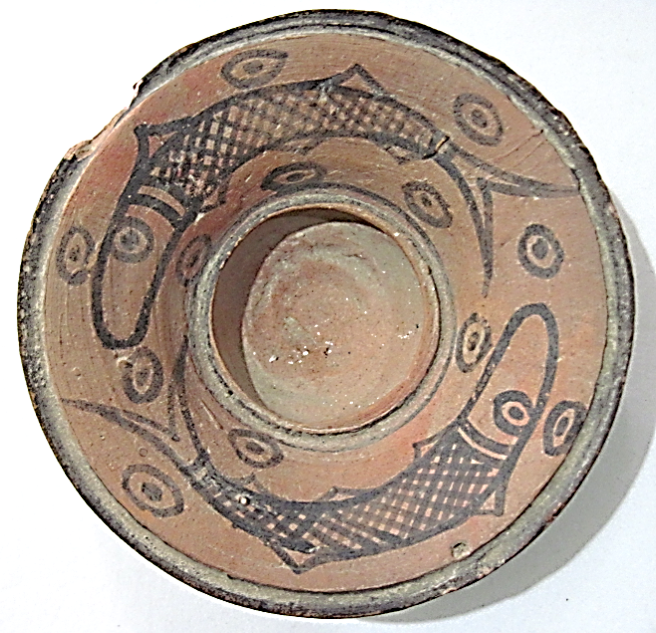

Figs. 1-3. Indus-Bowl-Fish-*Liza alata*-Terracotta-2600-1900 BCE

**Case no.: 3**

**Accession Number: A1306**

**Formal Label:** Indus-Bowl-Fish-*Liza alata*-Terracotta-2600-1900 BCE

**Display Description:**

This bowl has two depictions of *Liza alata,* the diamond mullet, one of the very few species from Indian waters that has diamond-shaped scales*.* *Liza alata* is adapted to marine, freshwater and brackish waters. Adults inhabit coastal waters, estuaries and ascend rivers to slow moving fresh water and still lagoons and are often found in turbid water, over muddy substrates, and with well-substantiated aquatic vegetation where they feed on microalgae, detritus, terrestrial plant material, and aquatic insects. *Liza alata* is catadromous so that it migrates down rivers to the sea to spawn. Therefore, it was well adapted to the Indus River and its tributaries.

The fish Matsya (मत्स्य) in Hindu mythology is the first of ten Avatars (incarnations) of Vishnu, who is described in the *Matsya Purana* as the deity that saves Manu, a sacrosanct human, from the cosmic flood that destroys all the unrighteous.

The *Matsya Purana* was probably first collected in the third century AD/CE but sections may date to the first millennium BCE (or earlier as oral literature) before they were collected. “Puranas are a stratified literature. Each titled work consists of material that has grown by numerous accretions in successive historical eras. Thus no Purana has a single date of composition. (...) It is as if they were libraries to which new volumes have been continuously added, not necessarily at the end of the shelf, but randomly” (Dimmitt and van Buitenen 2012: 5).

Given the proposed dating of this bowl to ca 1900 BCE with images of *Liza alata* as one representative of Matsya’s fish, we suggest that oral portions of the myth situate it on the same time horizon as the Noah flood myth in the Hebrew *Bible* and the [Gilgamesh flood myth](https://en.wikipedia.org/wiki/Gilgamesh_flood_myth) in Mesopotamia.

**LC Classification:** DS486 H35  
**Date or Time Horizon:** 2600–1900 BCE

**Geographical Area:** Mohenjo Daro

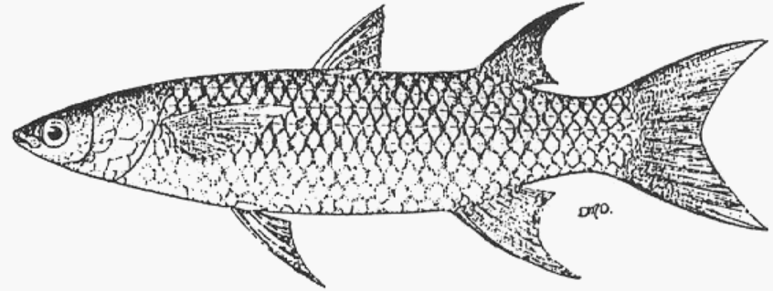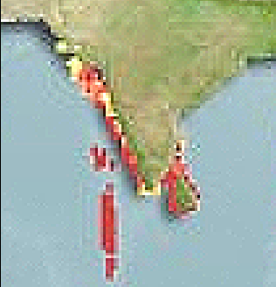 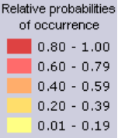

Fig. 4. *Liza alata*  (Steindachner, 1892) from Harrison and Senou 1997.

Fig. 5. Computer generated map of distribution of *Liza alata* in the Indian sub-continent and Indian Ocean area.  <http://www.aquamaps.org/imagethumb/file_destination/pic_Fis-26729.jpg>.  [(Kaschner](http://www.aquamaps.org/receive.php?type_of_map=regular:%20(Kaschner) et al. 2016).

**Map, GPS coordinates:**

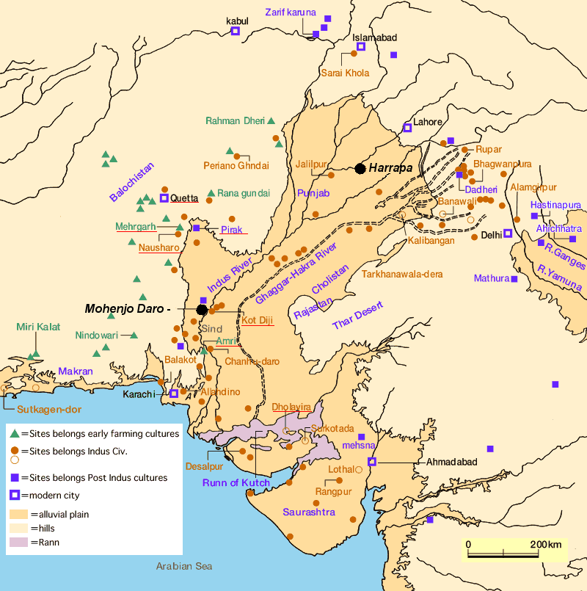

Fig. 6. Map of Indus sites from https://encrypted-tbn0.gstatic.com/images?q=tbn:ANd9GcSnoolUCyM4saSet1fqKCqzYEWJhfDBzJsATILKpXYgG8P2maLY.

**GPS coordinates:** [27°19′45″N 68°08′20″E](https://tools.wmflabs.org/geohack/geohack.php?pagename=Mohenjo-daro&params=27_19_45_N_68_08_20_E_type:landmark)

**Cultural Affiliation:** Mohenjodaro area

**Media:** Terracotta, black, yellow, red and green pigment.

**Dimensions:** Dia 124.92, 4.92 in

**Weight: 180 gm, 6.25 oz.**

**Condition: original**

**Provenance:** UK Collection

**Discussion:**

The *Matsya Purana* in its third century AD/CE version presents the following story of the righteous man, Manu, who was saved by Matsya (from <http://www.bharatadesam.com/spiritual/matsya_purana.php>):

**Vishnu and Manu**  
  
There used to be a king named Manu. He was the [seventh] son of the sun-god [Vivasvana]. When it was time for Manu to retire to the forest, he handed the kingdom over to his son [Ikshvaku]. Manu then went to the foothills of Mount Malaya and started to perform tapasya [meditation]. Thousands and thousands of years passed. Such were the powers of Manu’s meditation that Brahma appeared before him. "I am pleased with your prayers," said Brahma. "Ask for a reward." "I have only one reward to ask for," replied Manu. "Sooner or later there will be a destruction [*pralaya*], and the world will no longer exist. Please grant me the reward that it will be I who will save the world … at the time of the destruction." Brahma readily granted this reward. Days passed.

One day Manu was performing ablutions in a pond near his hermitage. He immersed his hands in the water so that he might offer some water to his ancestors. When he raised his cupped hands, he found that there was a minnow [*shafari*] swimming around in the water. Manu had no desire to kill the minnow. He placed it carefully in his water-pot [*kamandalu*].  But the minnow started to grow and within a day, it was sixteen fingers in length. "Save me, king." said the fish. "This water-pot is too small for me."  
 Manu then placed the fish in a vat. But the fish continued to grow and, within a day, it was three hands in length. "Save me, king." said the fish. "This vat is too small for me." Manu put the fish in a well, but the well soon became too small for the fish. Manu transferred the fish to a pond, but the pond was also too small for the fish. Manu now removed the fish to the holy river Ganga, but even this was too small for the fish.

Finally, Manu transferred the fish to the ocean. There the fish grew so much that it soon occupied the entire ocean. "Who are you?" asked Manu. "I have never seen or heard of such wonders. Are you a demon that is deluding me with its illusions? No, I do not think that you are a demon. You must be the great Vishnu himself. Please tell me the truth and satisfy my curiosity."  
 Vishnu then revealed that it was indeed he who had adopted the form of a fish. He told Manu that the earth would soon be flooded with water. Vishnu had got a boat built by the gods. [In other accounts, Manu was himself asked to construct the boat]. When the earth was flooded, Manu was to place all living beings in the boat and thus save them. Vishnu would himself arrive in his form of the fish and Manu was to tie the boat to the fish’s horn. Thus the living beings would be saved. And when the waters of the flood receded, Manu could populate the world afresh and rule over it. [This is the more customary account. But in the Mahabharata, it was Brahma who appeared before Manu in the form of a fish.]

Vishnu disappeared, and for a hundred years there was a terrible drought on earth. The drought led to famine and people died of starvation. Meanwhile, the sun blazed in fury and burnt up the entire world. When everything had burnt to ashes, dark clouds loomed in the sky.

These are the clouds that appear at the time of destruction and there are seven classes of clouds, known *as samvarta, bhimananda, drona, chanda, valahaka, vidyutapataka* and *kona*. From the clouds, rain began to pour and soon, water engulfed the entire earth. The land mass was flooded. As instructed by Vishnu, Manu gathered together [all the righteous] living beings inside the boat.

**References:**

Allen, G.R., 1985. FAO Species Catalogue. Vol. 6. *Snappers of the world. An annotated and illustrated catalogue of lutjanid species known to date.* FAO Fish. Synop. 125(6):208 p. Rome: FAO.

|  |
| --- |
| Dimmitt, Cornelia and van Buitenen, J. A. B., eds. 1978. *Classical Hindu Mythology: A Reader in the Sanskrit Puranas.* Philadelphia: Temple University Press.  Harrison, I.J. and H. Senou, 1997. “Order Mugiliformes. Mugilidae. Mullets.” pp. 2069-2108. In K.E. Carpenter and V.H. Niem (eds.) *FAO species identification guide for fishery purposes. The living marine resources of the Western Central Pacific.* Volume 4. Bony fishes part 2 (Mugilidae to Carangidae). FAO, Rome. |

Gietz, K. P. et al. 1992. Epic and Puranic Bibliography (Up to 1985) Annotated and with Indexes: Part I: A - R, Part II: S - Z, Indexes. Wiesbaden: Otto Harrassowitz Verlag.

Kaschner, K., K. Kesner-Reyes, C. Garilao, J. Rius-Barile, T. Rees, and R. Froese. 2016. *AquaMaps: Predicted range maps for aquatic species*. www.aquamaps.org, Version 08/2016.

[Rocher, Ludo](https://en.wikipedia.org/wiki/Ludo_Rocher). 1986. *The Puranas*. Wiesbaden: Otto Harrassowitz Verlag.

Vasu, Sudhīndra Nātha. 1916. *The Matsya Puranam*, Part 1 of 3 (Chapters 1-128). Allahabad: Panini Office.

Vasu, Sudhīndra Nātha. 1917. *The Matsya Puranam*, Part 2 of 3 (Chapters 129-199). Allahabad: Panini Office.